Pizza Sales SQL Query
A.KPI’s
1.Total revenue
select sum(total_price) as total_revenue from pizza_sales.pizza_sales;
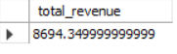
2. Average order value
select sum(total_price)/ count(distinct order_id) as avg_order_value from pizza_sales.pizza_sales;

3.Total pizza sold
select sum(quantity) as Total_pizza_sold from pizza_sales.pizza_sales
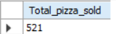
4.Total orders
select count(distinct order_id) as Total_orders from pizza_sales.pizza_sales;
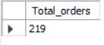
5.Average pizza per order
select Cast(sum(quantity)/ count(distinct order_id) as decimal (10,2)) as avg_pizza_perorder from pizza_sales.pizza_sales;
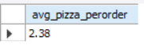
6.Daily trend for total orders
SELECT order_day, total_orders
FROM (
SELECT DAYNAME(STR_TO_DATE(order_date, '%d-%m-%Y')) AS order_day, COUNT(DISTINCT order_id) AS total_orders
FROM pizza_sales.pizza_sales
GROUP BY DAYNAME(STR_TO_DATE(order_date, '%d-%m-%Y'))
) AS t
ORDER BY FIELD(order_day,
'Monday','Tuesday','Wednesday','Thursday','Friday','Saturday','Sunday');
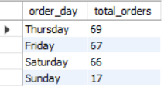
7. Hourly trend for total orders
SELECT HOUR(order_time) AS order_hour, COUNT(DISTINCT order_id) AS total_orders FROM pizza_sales.pizza_sales
GROUP BY HOUR(order_time)
ORDER BY HOUR(order_time);
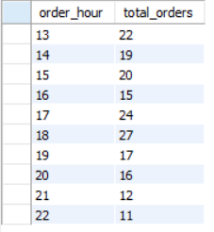
8. Pizza category
Select pizza_category, sum(total_price) as Total_Sales, sum(total_price) * 100/
(select sum(total_price)from pizza_sales.pizza_sales ) as PCT
from pizza_sales.pizza_sales
group by pizza_category
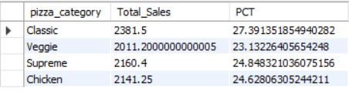
9.Pizza Sizes
Select pizza_size, sum(total_price) as Total_Sales, sum(total_price) * 100/
(select sum(total_price)from pizza_sales.pizza_sales ) as PCT
from pizza_sales.pizza_sales
group by pizza_size
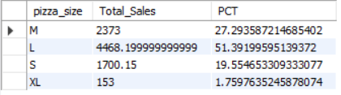
10.Total pizza sold by pizza category
select pizza_category,sum(quantity) as Total_pizzas_sold
from pizza_sales.pizza_sales
group by pizza_category
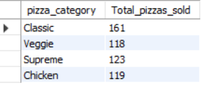
11. Top 5 bestsellers from total pizza solds
select pizza_name, sum(quantity) as Total_pizza_sold
from pizza_sales.pizza_sales
group by pizza_name
order by Total_pizza_sold desc limit 5
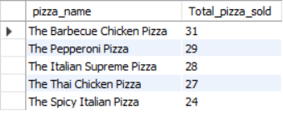

12. Bottom 5 pizza solds
select pizza_name, sum(quantity) as Total_pizza_sold
from pizza_sales.pizza_sales
group by pizza_name
order by Total_pizza_sold limit 5
